How to use word-by-word translations

These resources can be used in a number of ways to enhance the English speaker’s understanding of the Pāli chanting that is regularly chanted by the monastic and lay communities in Western Ajahn Chah monasteries.

However, it should be clearly stated that these translations are created by LLMs, are not scholarly and are no replacement for the actual study of Pāli. Readers would do well to further investigate the meaning of the chanting using tools such as https://simsapa.github.io/.

That being said, effort has been made to ensure that the translations are at least ‘good enough’ and in general are a reliable reflection of the meaning of the chanting.

For those interested in furthering their study of Pāli, a good place to start would be https://pali-sutta-readings.github.io/pali-lessons/.

For those who just wish to know the meaning of a particular word in a particular chant, it is simply a case of navigating to the relevant chant and looking that word up. It is usually worth looking at the word in the context of the phrase in which it appears and the various line-by-line translations of that phrase to get a more rounded sense of the word.

Readers may also wish to consult this Pāli grammar cheat sheet for further information on the grammar of a word.

For those who wish to learn the word-by-word meaning of the chanting such that they understand the meaning of the chanting as they are chanting, using a Spaced Repetition System (SRS) is invaluable.

In effect a SRS is a way of using flashcards to gradually move individual pieces of information (the meaning of a word, a grammar point, a sutta reference, etc.) from short-term memory to long-term memory by gradually increasing the interval between reviews of each flashcard over a period of months.

See this YouTube video or this article for more information. For a deep dive on SRSs see Gabriel Wyner’s Fluent Forever.

There is a free SRS app called Anki which can be used on windows, android, MacOS, or iPhone (for iPhone there is a charge for the app, although it is still free to use via a browser.) For information on using Anki see this article which includes links to a series of YouTube videos.

For those who don’t have sufficient access to a computer and/ or smartphone, or for those who wish to avoid interacting with screens, it is possible to make a paper based SRS using a Leitner Box.

Learning the Word-by-Word Meaning of the Chanting

Making a Leitner Box

(N.B. The principles laid out below equally apply to the creation of digital flashcards using a SRS app like Anki. See this article for a guide on using Anki.)

To make a Leitner box you will need:

- Plain paper (it has to be blank on both sides) cut into as many flash cards as you need
- A pen to write the words/ translations
- A different colour pen to mark the front side of each card
- 9 envelopes or boxes in which to keep the flashcards
- A Leitner box schedule so that you know which flashcards to review when. You can find an example here.
- Some kind of container to keep everything together
- Optional: paperclips to group pre-prepared flashcards and/ or to keep the envelopes closed (you’re going to end up with a lot of flashcards, you won’t want them to fall out of the envelopes)

Basic flashcards

Each flashcard will enable you to learn one piece of information. For an unfamiliar word, that will be the meaning of that word.

Let’s take the example of:

Yathā vāri-vahā pūrā paripūrenti sāgaraṁ
Literal: Just as water-carriers full fill up the ocean
Faithful: Just as rivers, when full, fill up the ocean
Word | Analysis & Meaning
yathā | (ind) as, just as; [ya + thā]
vāri-vahā | (masc nom pl comp) water-carriers, rivers; [vāri + vaha]
↳ vāri | (nt comp) water; [vāri, no root in DPD]
↳ vahā | (masc nom pl) carriers, those that carry; [√vah + a]
pūrā | (masc nom pl) full, filled; [√pūr + a]
paripūrenti | (3rd pl pres act indic) fill up, fill completely; [pari + √pūr > pūre + nti]
sāgaraṁ | (masc acc sg) ocean, sea; [sāgara, no root in DPD]

On the front of the flash card write the new word ‘Yathā’. Put a red dot (it can be any colour) in the top left hand corner to mark that this is the front side of the card.


Now write the translation on the back of the card.


To really embed the meaning of the word in your brain, you’ll have to make both Pāli-English and English-Pāli cards. So for ‘Yathā’ you’ll also make:

If you carry on with the rest of this line, you will end up with a total of 14 cards reading:

Yathā/ Just as - Just as/ Yathā
vāri/ water - water/ vāri
vahā/ rivers - rivers/ vahā
pūrā/ full - full/ pūrā
paripūrenti/ (they) completely fill - (they) completely fill/ paripūrenti
sāgaraṁ/ (to the) ocean - (to the) ocean/ sāgaraṁ

Tip: Each flash card can be flipped on its long or short edge. It doesn’t really matter which way you choose, but in the long run you’ll save time if you flip the cards on their long edge. Whichever way you choose, be consistent from the start.

Tip: Your brain finds it much much easier to remember images than text, so when learning words like vahā/ rivers or sāgaraṁ/ ocean, generate a mental image of a river or the ocean every time you review it. Make sure you generate the same image every time. You’ll be surprised that when you come to review these cards weeks or months later, the image will just pop into your mind, and might even start to do so whilst you’re chanting.

Whole phrase flashcards

You can also learn the meaning of words in the context of the phrase. This is actually more useful as your brain will over time begin to learn Pāli grammar in the background without you even noticing. However the downside is that if you’re doing this by hand it takes longer to create each flashcard. For example:




Another option would be:

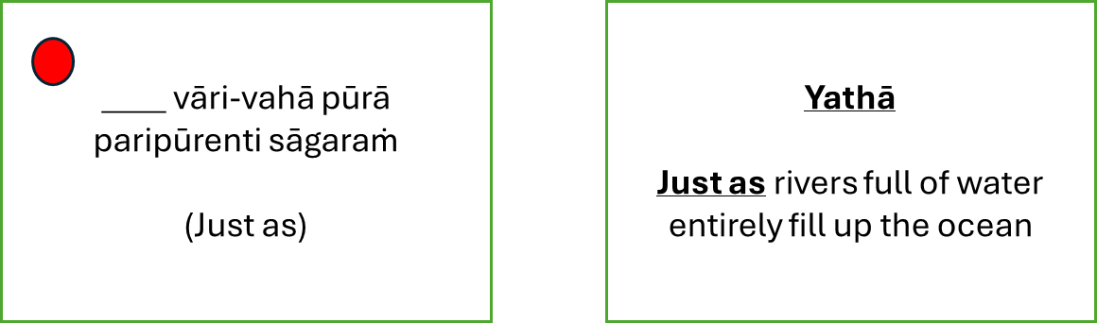
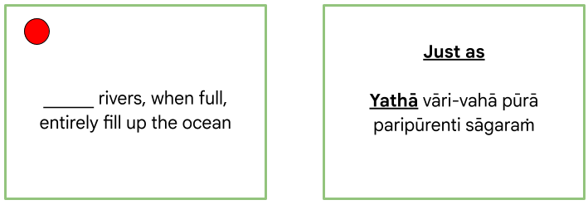

Grammar flashcards

To learn grammar, you will need a grammar guide, for example this Pāli grammar cheat sheet. Let’s go back to our sentence:

Yathā vāri-vahā pūrā paripūrenti sāgaraṁ

Just as rivers full of water entirely fill up the ocean

The sentence is indicating that water is moving from the river to the sea. In Pāli this is indicated through the accusative case. Checking a Pāli grammar guide, we will see that for singular masculine nouns, the accusative is formed by adding -ṁ to the stem of the noun. To isolate this piece of information, we need to highlight just the case ending as demonstrated below:


Grammar is almost always better learnt in the context of a sentence or phrase, so the below will work better, but take longer to write out. However, you cannot always produce a neat English-Pali version of the card. You can compensate for this by making further cards that capture the accusative case ending -ṁ from other sentences as you come across them.

Tip: You can add extra information to cards to capture wider information such as the case of the word if you find that useful, for example:

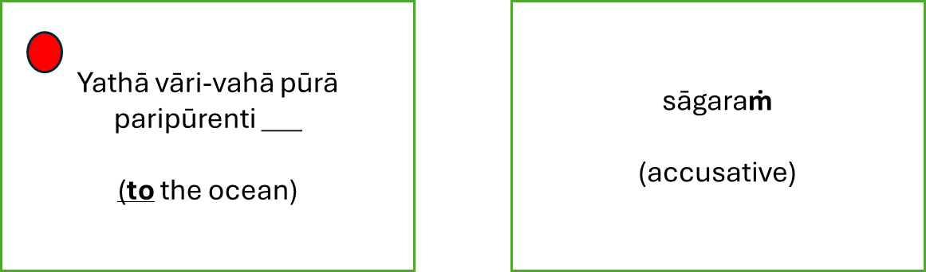
If we wanted to capture the third person plural present tense conjugation of paripūreti, having once again consulted a Pāli grammar guide, we could make the following cards:

Tip: Eventually you will have a great many cards, so it can be useful to add a context to cards so that their meaning from the chant they appear in jumps out. For example:



Once again, if you are willing to put in the extra time then presenting the conjugation in context that would work best.

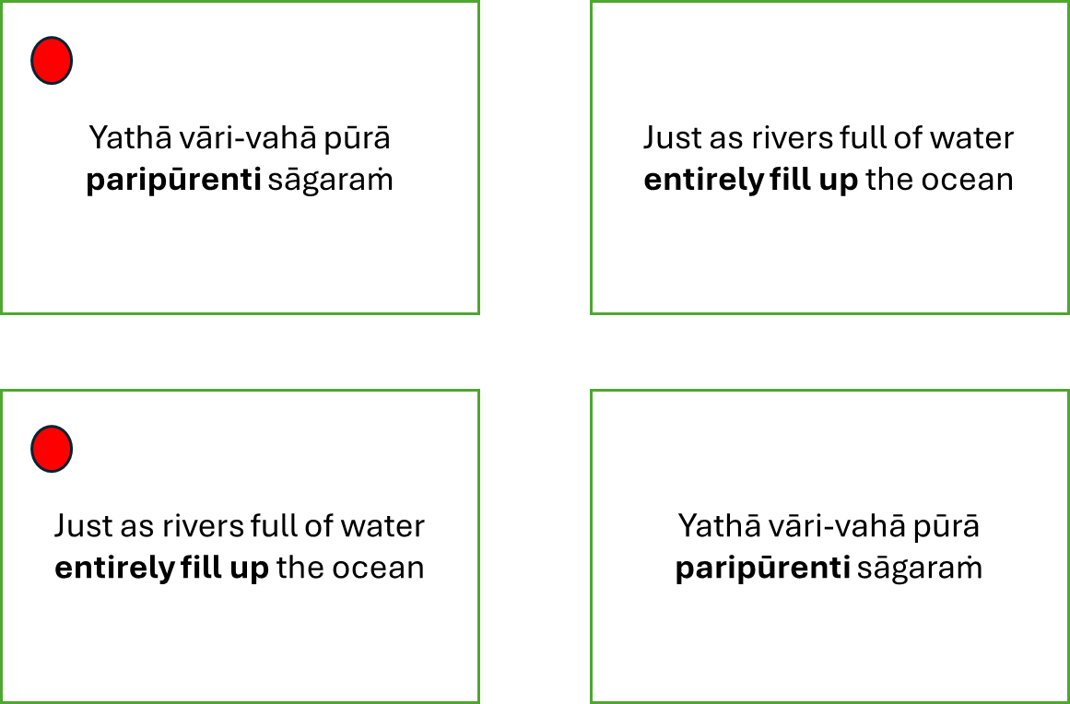
Once you’ve produced all these cards, you’ll be able to produce a literal translation of the phrase and your own English rendering:

Yathā (just as) vāri (water)-vahā (carriers) pūrā (full) paripūrenti (they completely fill) sāgaraṁ (to the ocean)

Just as the water from abundant rivers completely fill the ocean with their water

Reviewing the flashcards

Once you have your flashcards they are ready to be entered into a Leitner box. Get nine envelopes (or equivalent flashcard containers) and label them 1 through to 7, then 8A and 8B, on the front and back. There will be one envelope for each ‘review level’ in the schedule. Print out the Leitner box schedule and fill in the dates. Day 1 is whatever day you are starting.

Put your prepared cards into Level 1.

Tip: For the first few days only enter ten cards into the system until you get the hang of how it works. When you feel confident you can add as many cards as you wish, but 20 is generally enough. Remember that further down the line there will be days when many cards are reviewed such that you will get overwhelmed if you add too many cards early on.

Tip: You can prepare many flashcards in advance and keep them in a ‘holding envelope’. This is especially useful if you know that you’ve got a busy period coming up. If you do this, it can be handy to use paperclips to group a day’s worth of cards together. Store them in such a way that it is easy to add the groups of cards to the Level 1 envelope in order, i.e. in the order in which the words in the cards appear in the chant you are learning.

Tip: Arrange your cards so that for Level 1 you review the English cards first to prime your brain. You’re unlikely to remember the Pāli straight away. This is easiest done as you are making the cards, just make one pile of new Pāli cards and one pile of new English cards.

Then review the cards one by one. If you get a card correct, it moves up a level (i.e. it goes into the next level’s up envelope, so if you’re reviewing a Level 1 card it moves to Level 2). If you get a card wrong, it gets moved down a level. For level one cards, keep reviewing them until you get it right and it moves to level two. On any given day, use the schedule to work out which cards you should be reviewing. Always review cards from the highest level first, then work your way down.

Carry on like this until a card is reviewed at Level 8A or B, at which point it can be discarded. After day 256, the Leitner schedule loops back on itself, so the next day is day 1. You just carry on until all your cards are successfully reviewed at Level 8A or B.

Tip: Do your reviews everyday, even if you’re busy. If you start missing days the reviews will start piling up which can be discouraging. If you do miss a day, then review all the cards from the missed day(s) and from the current day. As ever, start with cards from the highest level and work your way down.

Tip: Review every card at least until Level 7. If, having reviewed a card at level 7 and having gotten it correct, you are completely confident you‘ve nailed its meaning then you can discard it. Otherwise only discard a card when it has been correctly reviewed at Level 8A or 8B.

Maintaining a positive attitude in the face of a daunting project

Learning the meaning of all of the Pāli chanting word-by-word is a big task and is likely to take a while, perhaps years. Here are some tips for maintaining a positive attitude throughout the journey:

- Rejoice in the ridiculous
People do ridiculously difficult things all the time. They run marathons, learn languages, learn instruments and build all sorts of projects from scratch into things that never before existed in the world. What makes them seem ridiculous is how distant they are from where we are now. But actually when you break them down, they are just a large number of small steps that need to be taken. Even if it were to take ten thousand flashcards to learn the word-by-word meaning of the chanting, the making and reviewing of each individual flashcard is simple. If you keep doing it, then slowly the ridiculous becomes the doable and then the done.
- Success is not having given up
If you define success as completion of the task, then you’re failing until the final flashcard is reviewed at Level 8A or B. That might take a while. Instead just redefine success as not having given up. Then you’re succeeding the whole way!
- Look back not forward
The end of the task is going to be in the distance for a long time, so you’ll get discouraged if you focus on how much you have left to do. Instead keep looking back at what you have done. This will quickly seem to grow in just a week or two and you’ll notice the difference when you start understanding even just part of a common chant as you’re chanting it. So keep looking at what you have done and don’t pay attention to how much you have left.
- Trust the process
After the honeymoon period where you’re getting your head around the novelty of how the system works, it’s easy to lose hope that this is all worth it, especially if we haven’t used a SRS before. At this stage you just have to keep your head down and trust that the process will produce fruit further down the line. SRSs work. Once you understand the meaning of one or two common chants as you are chanting them, then you’ll have all the evidence you need that the process works and that it is worth carrying on.
- Celebrate small wins
Don’t save the celebration for the end of the project, celebrate every day! Every time you finish a flashcard making session or a reviewing session acknowledge how well you’re doing, give yourself a pat on the back, go for a walk, listen to a Dhamma talk, whatever. It sounds silly, but you’ll actually start looking forward to attending to your Leitner Box if you know that you’re going to get a treat at the end.

- Keep up the momentum
Once you get into the rhythm of daily flashcard creation and reviewing, the process can seem to carry itself along. However, there will inevitably be a disruption to your routine (a big celebration in the monastery, a home visit, a retreat, etc) that can knock your Leitner Box off course.
Try to never let the process come to a stop. If you need to, you can reduce your flashcard creation so only a few cards are getting added to the system each day, or you can even stop adding any cards at all. But never stop reviewing the cards as they will pile up and you’ll soon get overwhelmed by the backlog. You might need to spread the reviews out over the day to get them in but just keep going. In the absolute worst scenario, never let a day go by where you don’t review any cards at all, even if it’s just one.

